Running in the night

Game Design Document

Zharylkhassynov Zhanibek

Description

Art theme
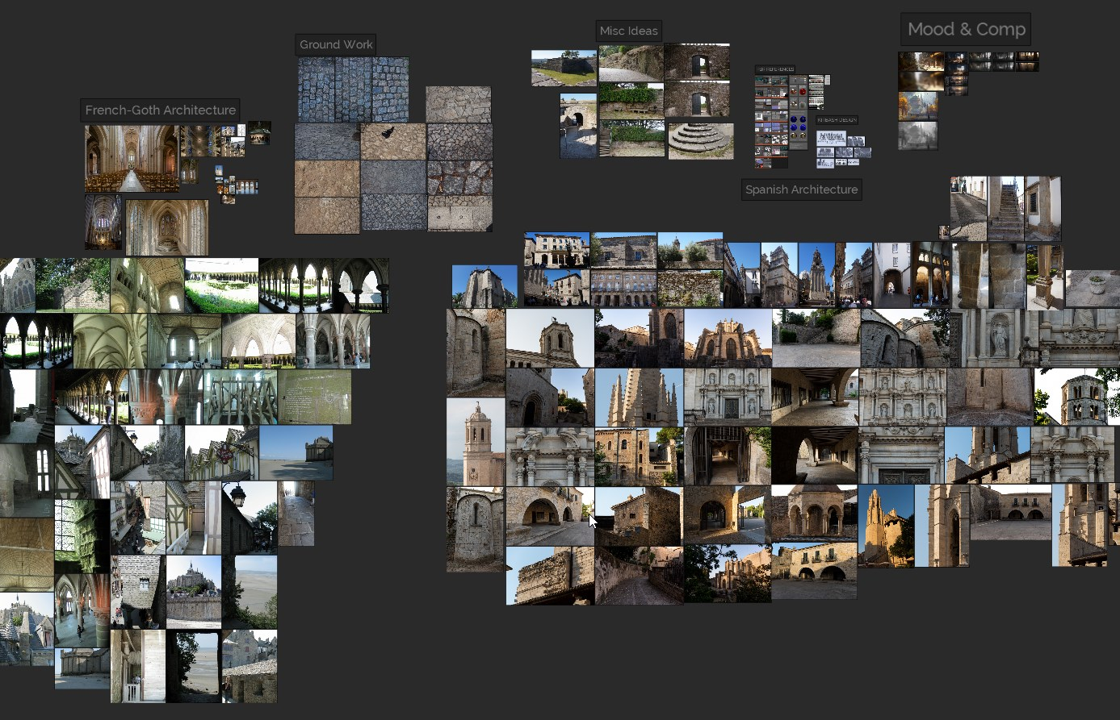

A brief description of the plot of the game.
A medieval knight runs across a bridge at night, overcoming obstacles at night in order to escape from a castle to collect a magic sphere. Player has to take “colleceble_skulls” as collectibles and “Yellow_sphere” to end level. Game made in a dark atmosphere and gothic style.

The place where the game takes place.
The place where the game takes place is in medieval times on the bridge that leads from the castle to the forest.

The main theme of the game.
The main theme of the game is to run across the bridge overcoming obstacles.

Typical play through of the game from start to finish
What happens? | The player runs across the bridge overcoming obstacles in the form of “Stationary_obstacle” and “Non-Stationary_obstacle”, simultaneously collecting “Score_collectable” and “End_level_collectable” to complete the game.
What does the player encounter? | The player meets along the way “Stationary_obstacle”, “Non-Stationary_obstacle”.

Core loop.
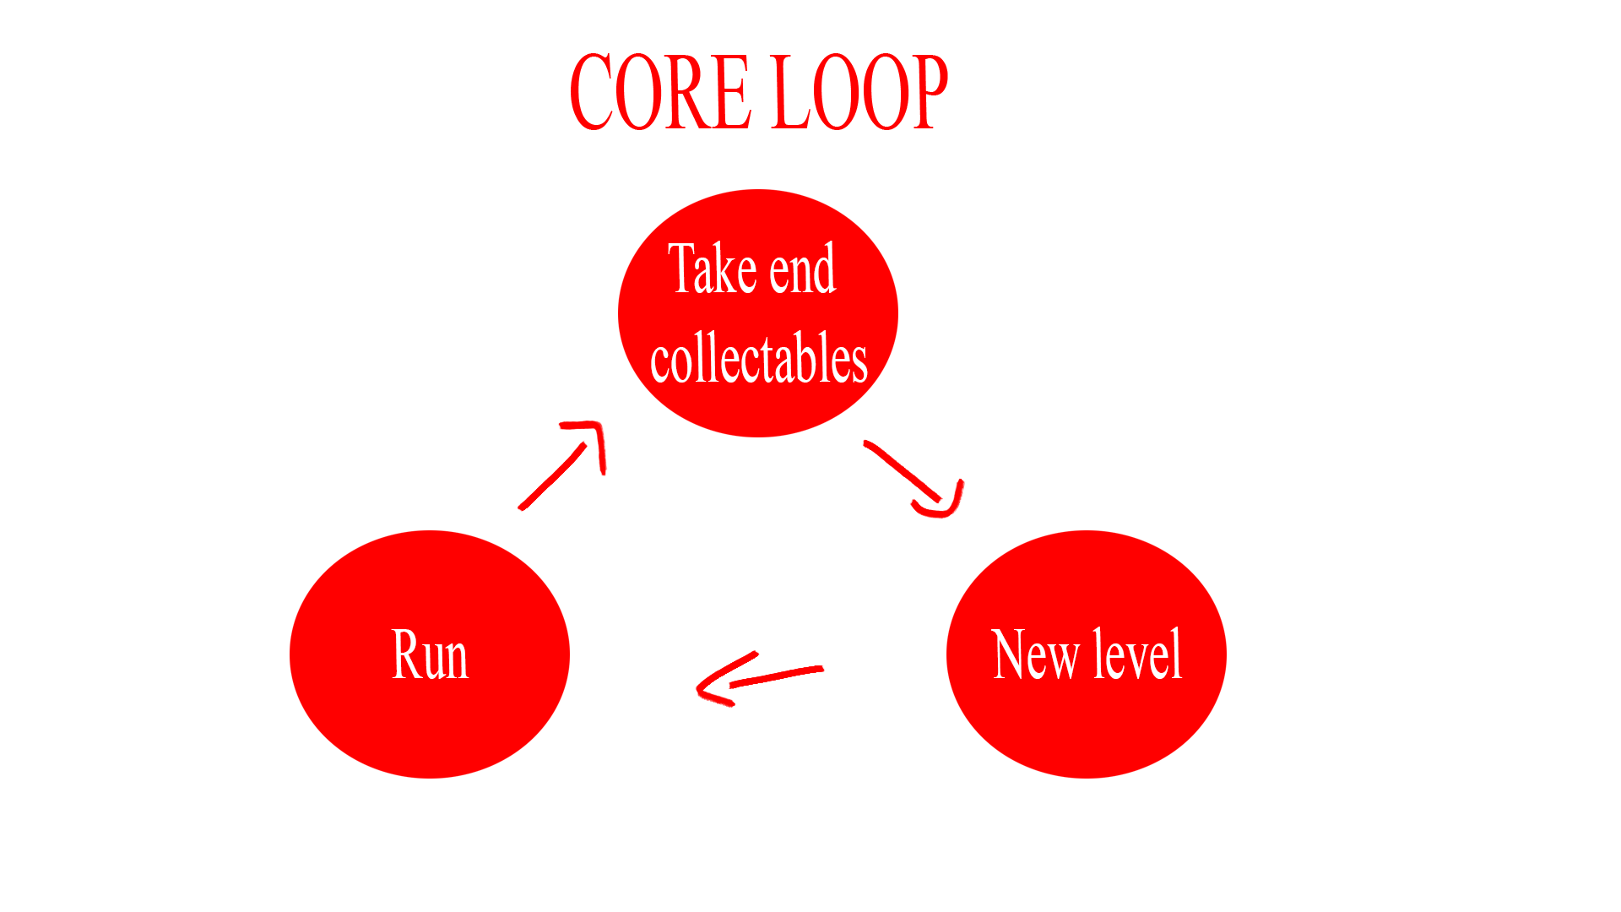

Concept Art or Models

Level layouts
Black is stationary obstacles, red is non stationary.
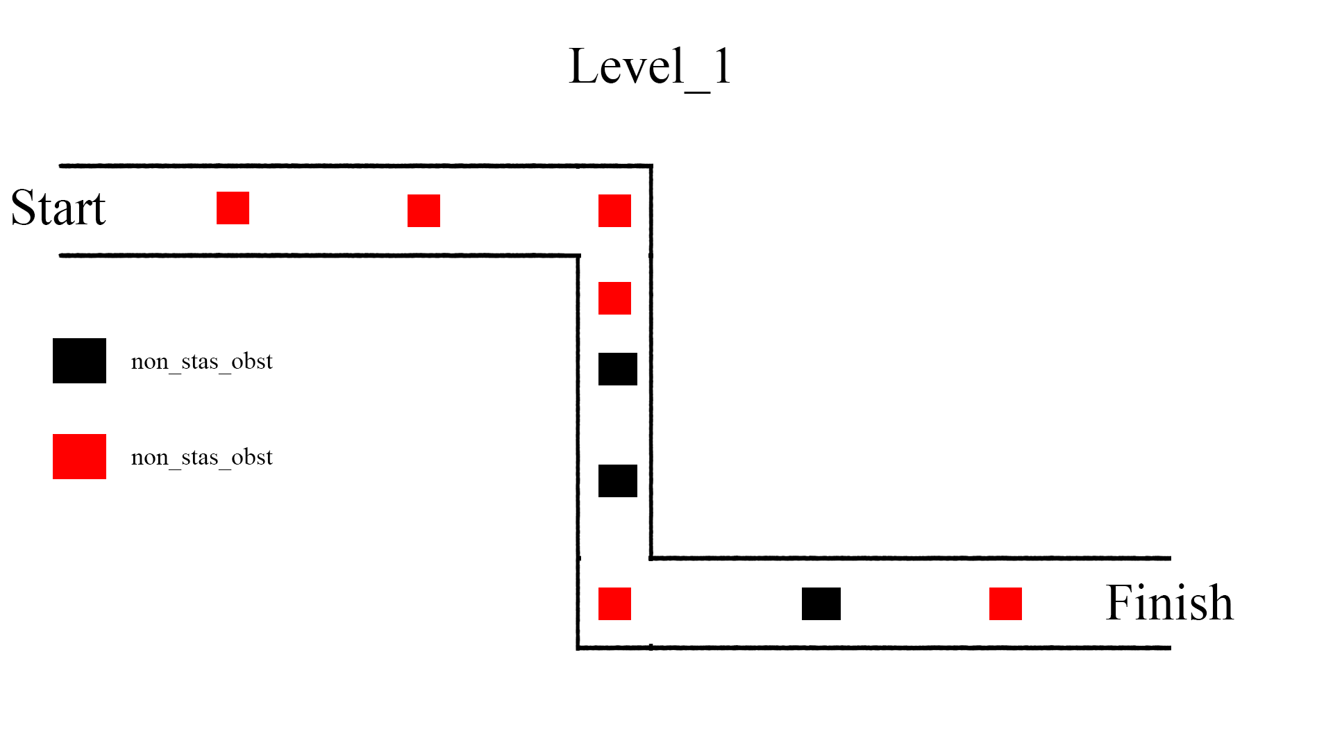
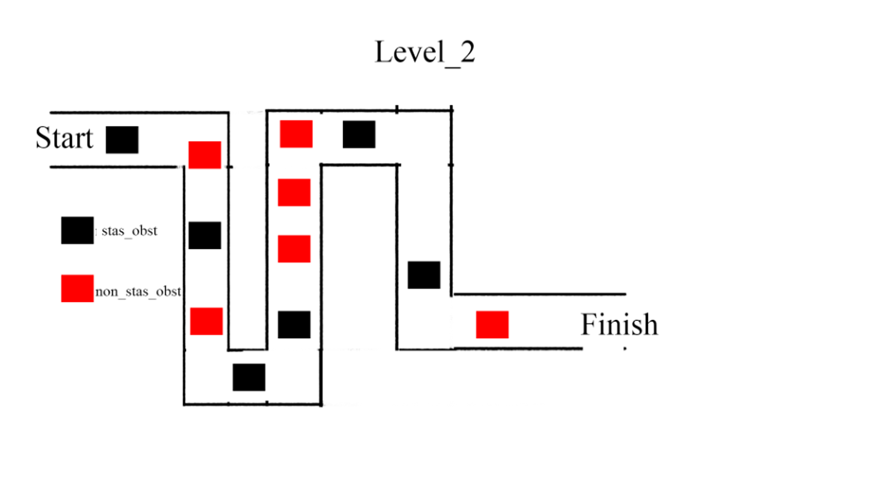

Environment assets
The bridge on which the player runs | 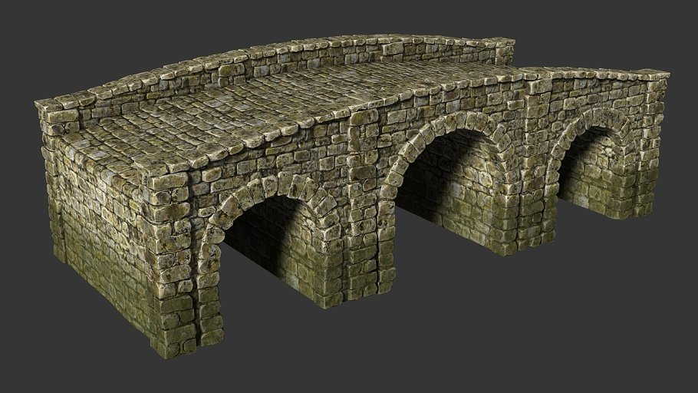
Props as decorative | 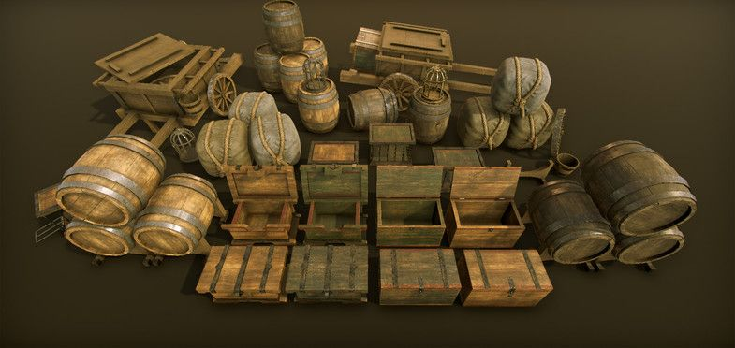

HUD
Score collectable quantity. | 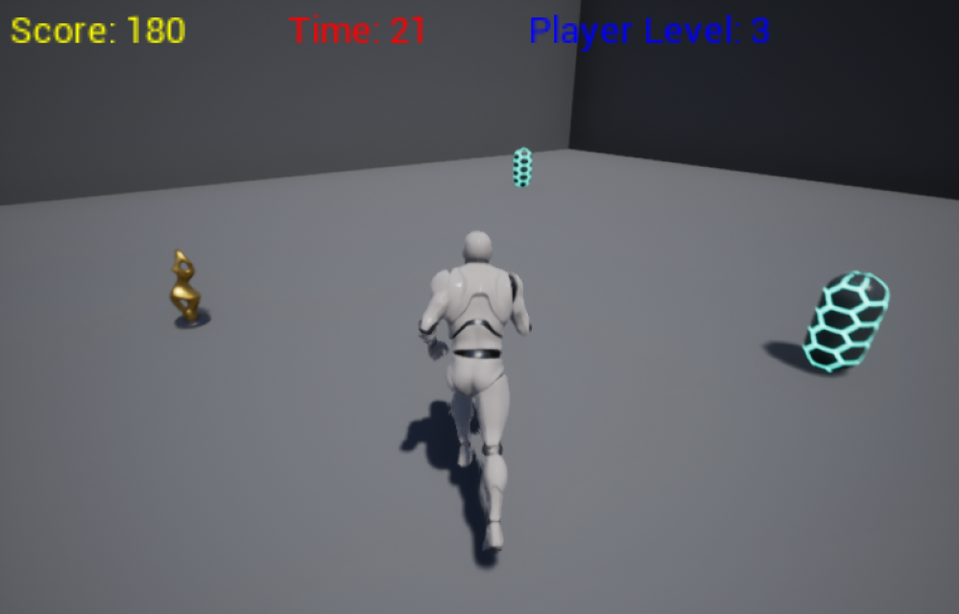
Player level.
Health level.

Description of the major assets

Obstacles
Stationary Obstacle
How does it look? | 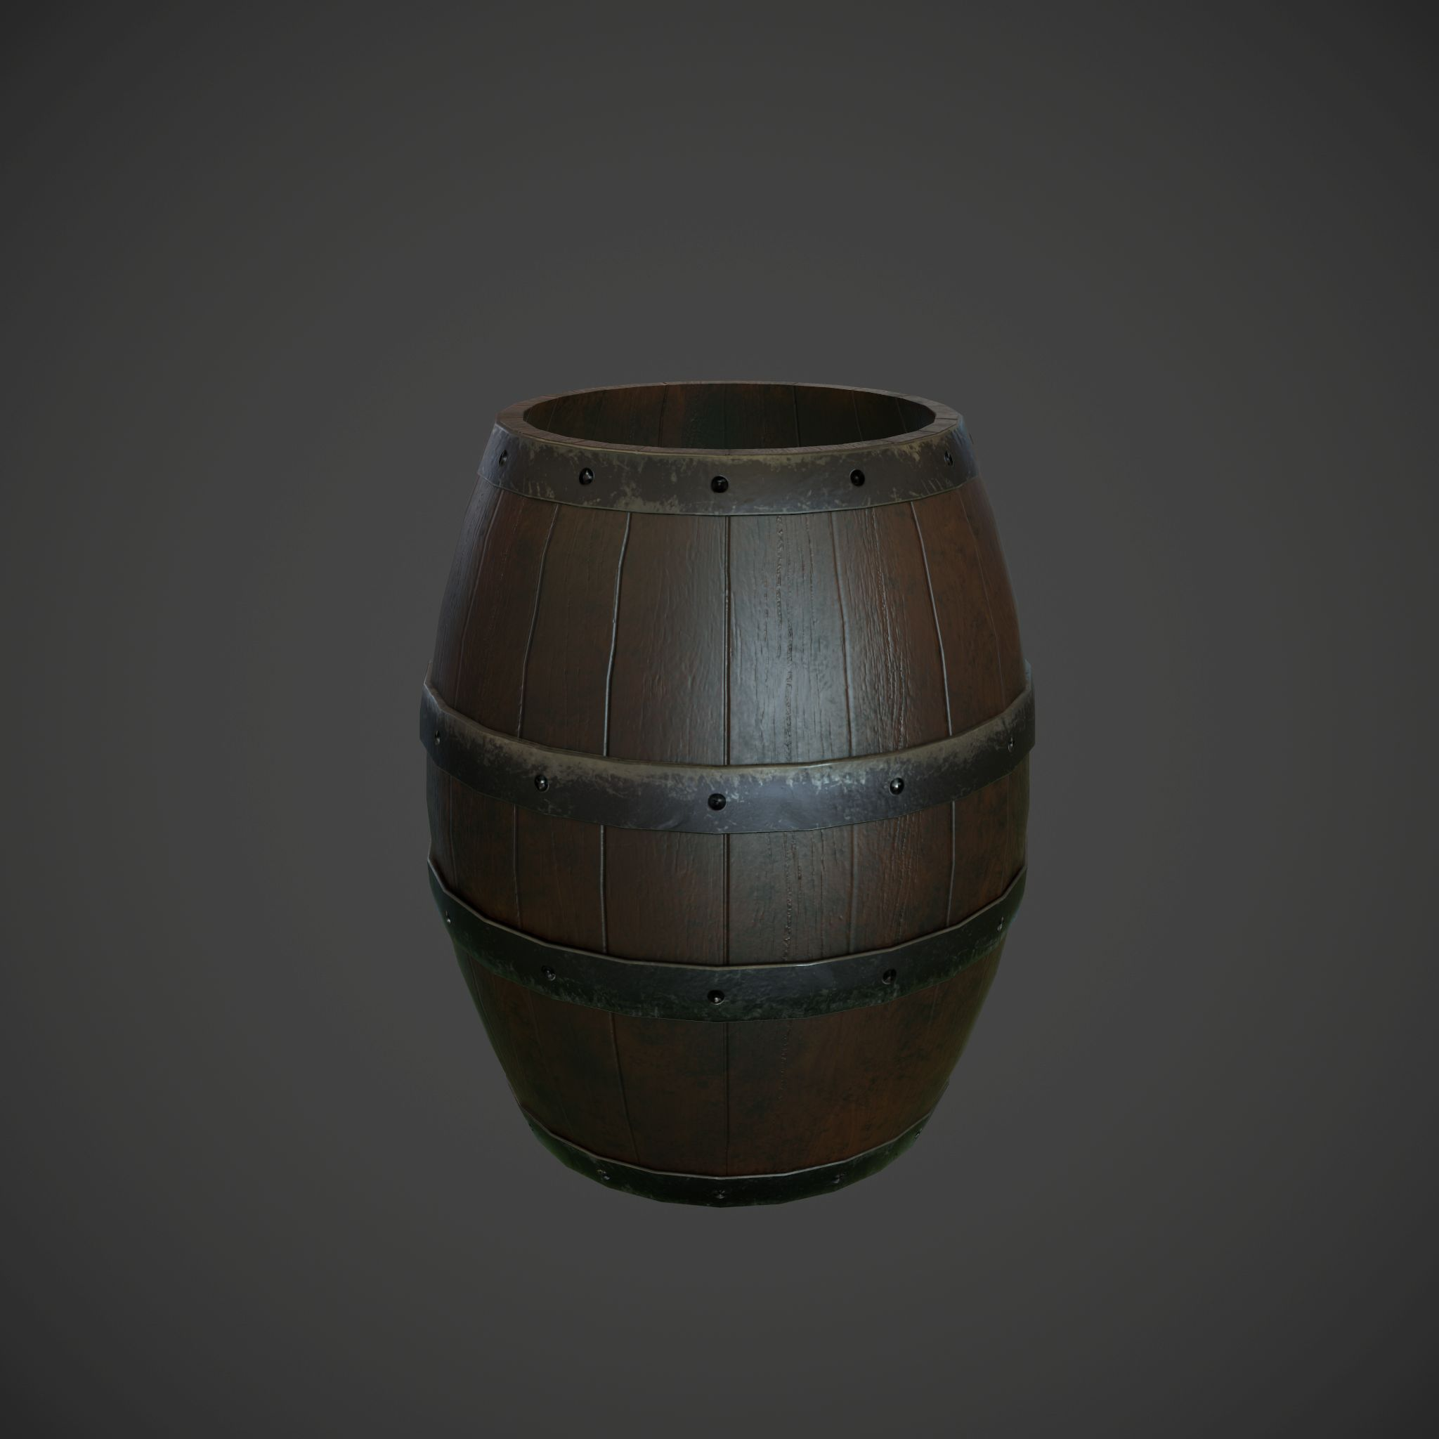
How does it work? | Player has to jump over it.
How does it affect the player? | Player dies when he does not jump over it. If the player jumps on the time, there is no affection.
Non-Stationary Obstacle
How does it look? | 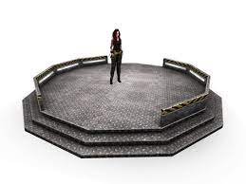
How does it work? | Flying platform. Simple animation back and forward
How does it affect the player? | The flying platform flies back and forth, the player needs to jump on it during.

Collectibles
Score collectable
How does it look? | 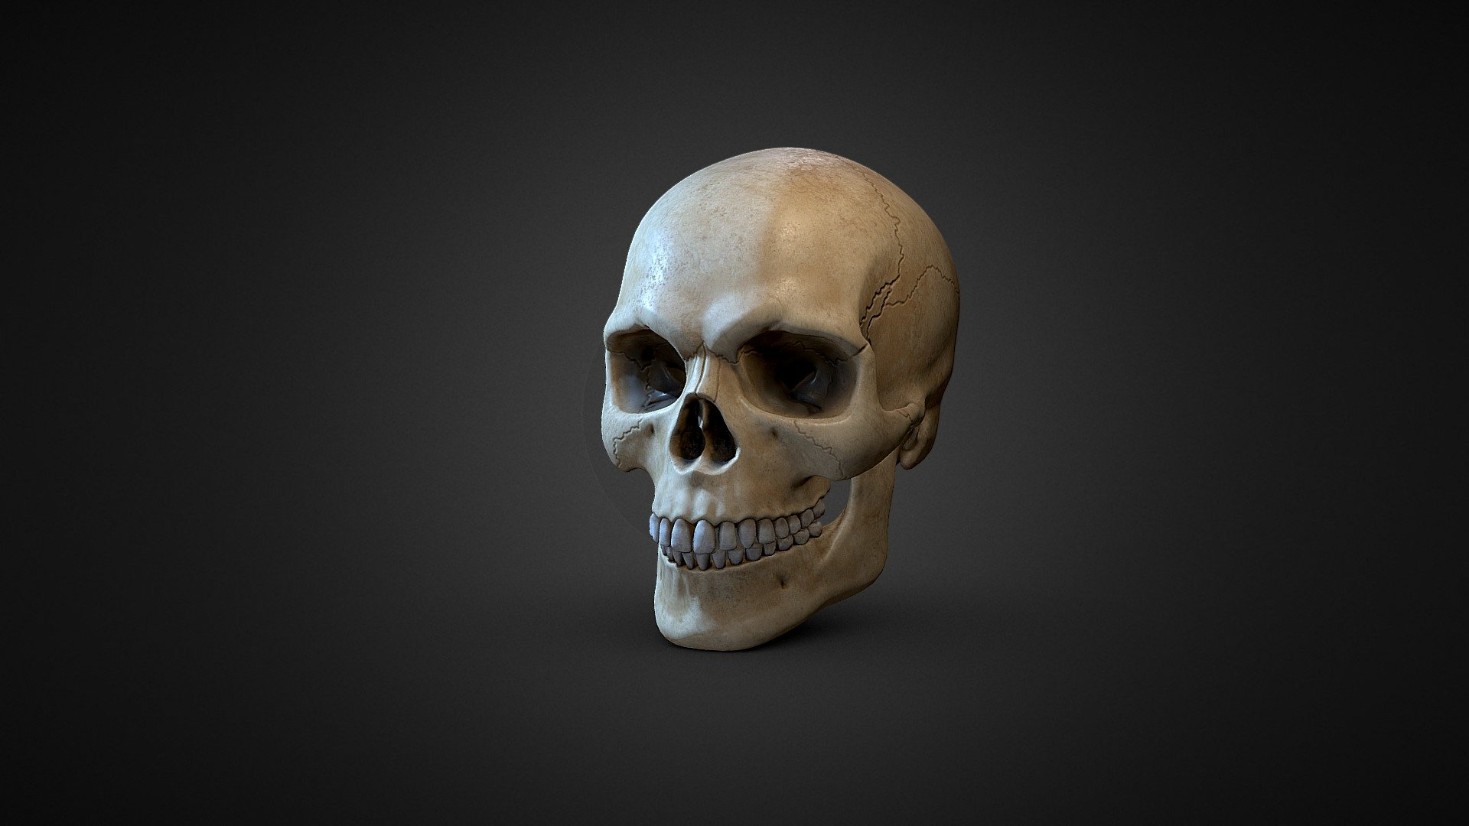
How does it work? | When a player goes into it he collects it. Collectables added to collectables score.
End level collectable
How does it look? | 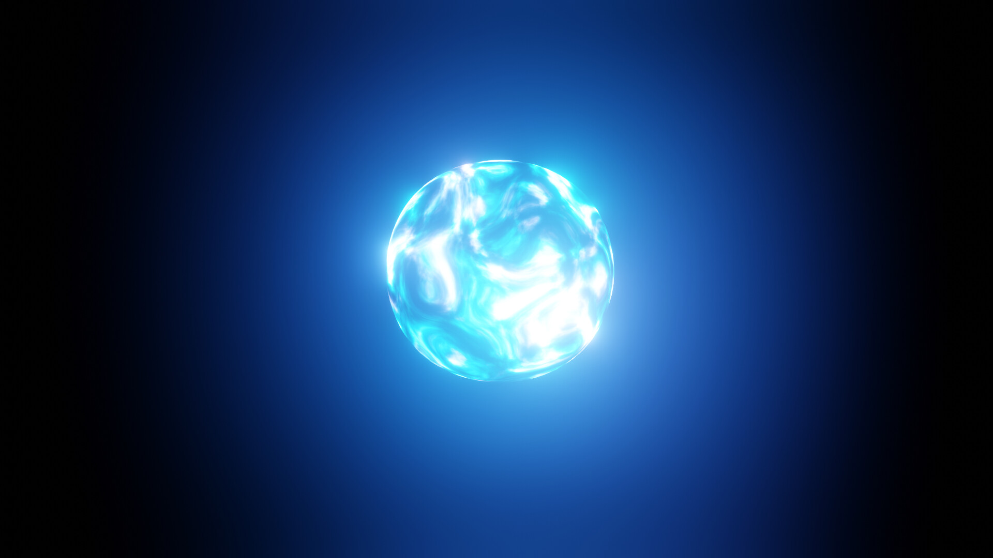
How does it work? | When a player goes into it he collects it. Collectable end level.

Sound
Background theme music. | Background_theme_music.mp4
Jump sound. | Jump_sound.4
Landing sounds. | Landing_sounds.mp4
Running sound. | Running_sound.mp4
Hitting object sound. | Hitting_object_sound.mp4
Dying sound. | Dying_sound.mp4
Collect score collectable sound. | Collect_score_collectable_sound.mp4
Collect level end collectable sound. | Collect_level_end_collectable_sound.mp4

